**Given ERD Diagram:**

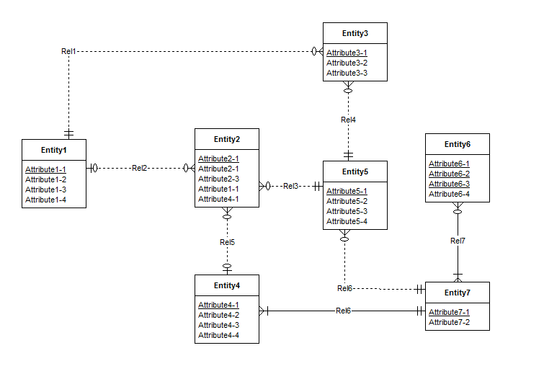

**Rule Violation:**

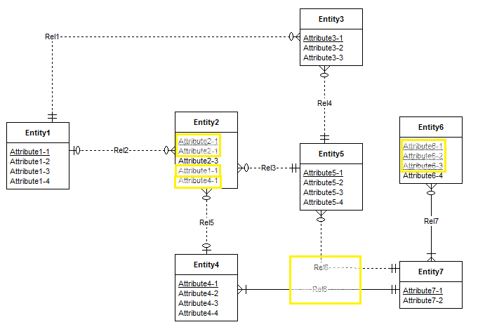

1. Unique key violation in Entity2 ("Attribute2-1")
2. Redundant Foreign Key in Entity2 ("Attribute1-1")
3. Redundant Foreign Key in Entity2 ("Attribute4-1")
4. Weak Entity ‘Entity 6’ is assigned with 3 primary keys
5. Identifying relationship violation for ‘Rel6’